STATS CHEAT SHEET

Eeeeeep! How do I decide which test to use?!

What type of data do I have?
Continuous Data Only
Categorical/Nominal data and Continuous data
Do I know the population μ and σ?
Yes

Run a Z - Test
No

No

Do I know the population μ?
Yes

Run a Single Sample T-test

- Use Sample
St. Dev. to predict σ
Run Correlation and/or Regression analysis

Do I have Independent Samples/Conditions?
Yes

No

Run a Paired Samples
T-Test

- aka Matched, Dependent, Test-Retest
Do I have 2 conditions
or More conditions?
2 Conditons

Run an Independent Samples T-Test

- Look for experimental groups
- Clues: Unequal N’s or Random Assignment to one or other group
3 or more Conditions

Run an ANOVA

- Look for experimental groups
- Clues: Unequal N’s or Random Assignment to one or other group

Nominal (Frequency) Data

Run a Chi Square

Z-TESTS

In order to run a Z-Test you must be provided with
- Population μ
- Population σ

Equation:
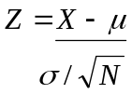

Critical Z-Test values:

 | 1-Tailed | 2-Tailed
α = .05 | 1.64 | 1.96/-1.96
α = .01 | 2.33 | 2.58/-2.58

EXAMPLE:

SINGLE SAMPLE T-TEST

In order to run a Single Sample T-test you must:
- Be provided with Population μ
- Use the sample Standard Deviation to predict Population σ

Equations:
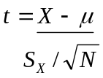 df = N – 1

EXAMPLE:

PAIRED SAMPLES T-TEST

Paired Samples T-Tests:
- Are also known as Dependent or Matched T-Tests
- Do not utilize population parameters, rather are a comparison of scores from a single sample measured across time
- Look for key words such as “Test-retest”; “Pre-Post”; “Same individuals tested”
- μ = 0

Equations:
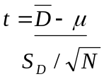 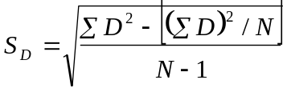 df = N - 1

Confidence Intervals: 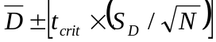
EXAMPLE:

INDEPENDENT SAMPLES T-TEST
(N’s Equal)
Independent Samples T-Tests:
- Are used to compare 2 Independent groups
- Have experimental groups / conditions
- May have unequal N’s
- Look for key words such as “Experiment”; “Conditions”; “Random Assignment to one condition or another”

Equations:
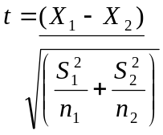 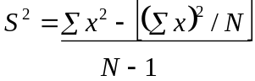 N = n₁ + n₂ df = N - 2

Confidence Intervals: 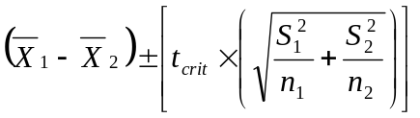
EXAMPLE:

INDEPENDENT SAMPLES T-TEST
(N’s Unequal)
Equations:
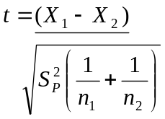 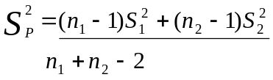 df = N – 2

Confidence Intervals: 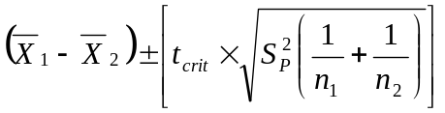

EXAMPLE:

ANOVA

ANalysis Of VArience:
- Are virtually the same thing as an Independent T-Test except that there are more than 2 conditions
- Accounts for possible inflation of the α level by dividing the α level between all possible comparisons (i.e. 3 conditions = α/3 .: α of 0.017 per comparison)

Equations:
Source | Sums of Squares  (SS) | df | Mean Square Error  (MS) | F
Between | =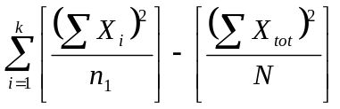 | k-1 | = 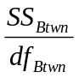 | = 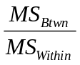
Within | SS_{Tot} - SS_{Btwn} | N-k | = 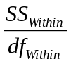 OR 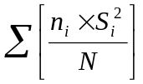
Total | =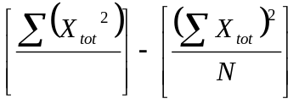 | N-1

Estimating the Magnitude of Experimental Effect:
(eta) = 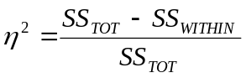 (omega) = 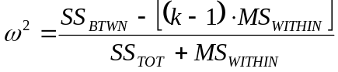

EXAMPLE:

CHI SQUARE

Chi Square:

  - Is used when you have ordinal data
  - You are using the obtained data to make a prediction about what the relationship would have been if there were no difference between the groups

Equations:
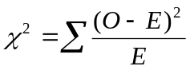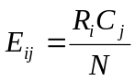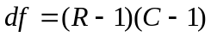
Likelihood Ratio: 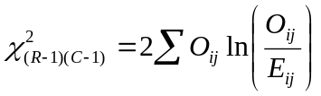

Measures of Association:
- Used to test the strength of the relationship
Phi: (2 by 2) 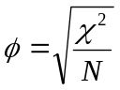
Cramér’s Phi: (X by X) 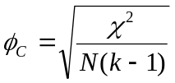
Odd’s Ratio: (2 by 2) 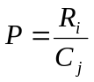

EXAMPLE:

CORRELATION AND REGRESSION

Correlation:
- Does not imply causation
- Determine if two sets of continuous data co vary / can one predict the other?
Regression:
- Is a way of predicting the score of the dependent (criterion) variable based on the level of the independent (predictor) variable

Correlation Equation:
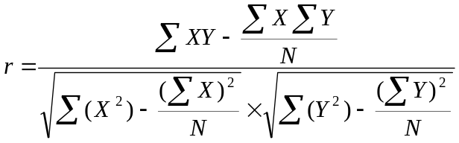

Regression Equations:
Y’= bX + a 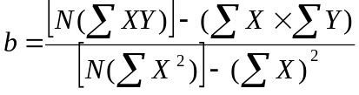 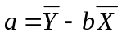
Standard Error of the Estimate:
S_{Y’} ² = S_{y}²(1-r²) 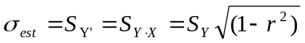
Confidence Limits on Y:
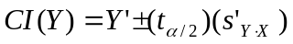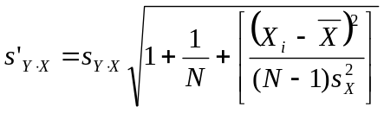
Note: for (t_{α/2}), if your α = 0.05, you would use the critical t value for α = 0.025.
Hypothesis Testing:
Testing r | Testing b | Testing Independent b’s
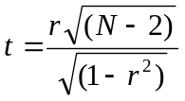 | 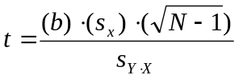 | 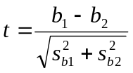
df = N - 2 | df = N - 2 | df = N - 4
 |  | 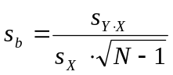

EXAMPLE:

POWER

Power Calculations:
- What is the probability of correctly rejecting a false H₀?
- Power is a function of:
  - α level
  - H₁
  - Sample size
  - Test statistic used
- Where n is unknown, used the power table to estimate δ on a given α level.

Power for 1 sample

Effect Size | Noncentrality parameter | Estimating Required Sample Size
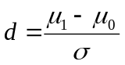 | 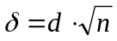 | 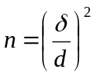

Power for 2 samples (N’s Equal)

Effect Size | Noncentrality parameter | Estimating Required Sample Size
 | 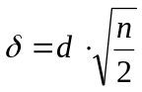 | 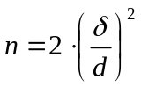

Power for 2 samples (N’s Unequal)

Effect Size  *Where σ is pooled | Harmonic N | Noncentrality parameter | Estimating Required Sample Size
 | 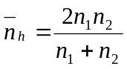 | 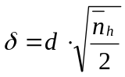

Power when ρ is known

Effect Size | Noncentrality parameter | Estimating Required Sample Size
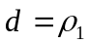 | 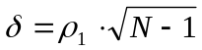 | 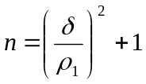

EXAMPLE:

